MA615 Berry assignment report

Name : Jinzhe Zhang

Due to there is only one factor that Value contain the numerical value in the table, I intend to focus on exploring the feature of this column. I learned from Zhou yinfeng, tried to split the data into to four different types of berry that are : chemical treat, fertilize treat, Tame, Wild. When I try to clean and organize the data, there are always some errors in my Rstudio. Finally, instead of using R to clean the data, I try to use EXCEL and Openrefine to clean and organize the data. The abbreviation is the first problem I encountered. To avoid the char type data, I used the filter function in EXCEL to find all abbreviation in the Value column and replaced them by 0. Honestly, it will be better if I replaced the abbreviation by the average of the rest of numerical value. However, since I tried to compare the total value in each state every year and there are zeros in every year, I think the sum of those value will offset the zeros bias effect.

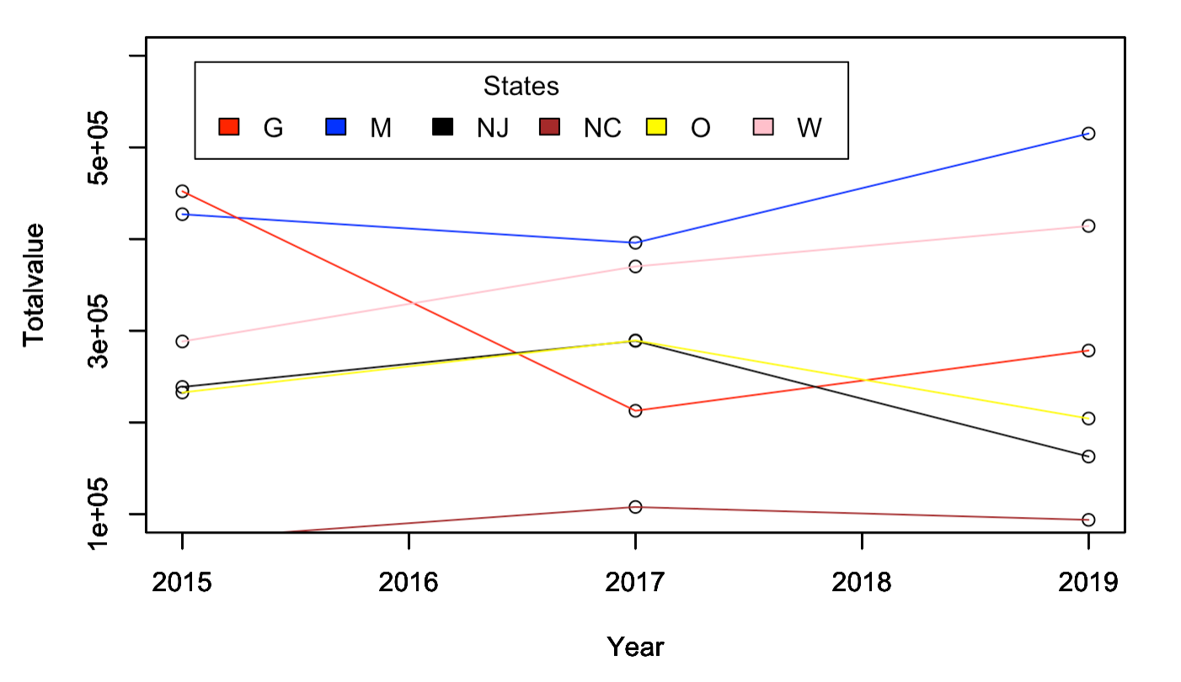

From this plot, it is clear that the MICHIGAN state nearly have the most valuable berries in those years with the chemical treatment. Washington's blueberry production is increasing year by year. From the plot we can see the value in 2019 is the lowest value for the states located in the South and East part of America while the value in 2017 is the lowest value for the states, OREGON and NORTH CAROLINA. Based on my research, I think that those changes are the results of Tropic storm and Hurricane.[1]

Planting blueberry trees should be placed in a sunny and humid place. They can withstand high temperatures. Even if the temperature is about 40℃ in the summer sun, they will not be scorched. As long as they are poured enough water, they will all be in the high temperature of 40-50℃. It can grow, but if there is insufficient light, blueberries will stop growing, and even if they bloom, they will not bear fruit. However, the tropic storm and the hurricane will destroy the everything that growing the berry need[2]. That is the part reason that I think the values changes in 2017,2019 those two year

1. #https://www.usda.gov/media/press-releases/2019/09/09/usda-resources-available-farmers-hurt-2018-2019-disasters
2. #https://www.hgtv.com/outdoors/landscaping-and-hardscaping/tips-on-growing-great-blueberries#:~:text=Blueberries%20are%20typically%20grown%20in,now%20has%20an%20enormous%20range.